Lung Health Today’s Date: __________________

1 - About Me
Name
Birth Year Gender

2 – My Body Reference Range BMI
Height cm Optimal: 18.5-24.9
Weight kg High Risk: <18.5 or
BMI kg/m² > 30
RR: _____________________ Usual RR: 12-20bpm

3 – My Breathing (circle): Chest / Diaphragm / Accessory muscles

4- My Lung Conditions (circle Y or N)
Asthma (childhood/adult/exercise induced) Y/N
COPD Y/N
Allergies Y/N
Sleep apnea Y/N
Lung infection in last 12 months Y/N

5 – My Symptoms (circle all that apply):
Shortness of Breath / Wheeziness / Pain with Breathing
Persistent Cough / Voice Hoarseness / Snoring
Appetite Loss / Weight Loss / Daytime Fatigue
Waking Up Choking or Gasping / AM Headaches

6 – My Current Medications

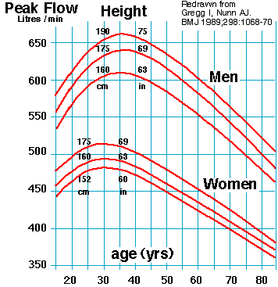
7. My Lung Function:
1. ___________ L/min
2. ___________ L/min
3. ___________ L/min

80-100% predicted
50-79% predicted
<50% predicted

8- My Risk factors (circle/check all that apply):
Smoker: Current / Recent / Second Hand Exposure
Cigarettes/day: _______ Years Smoking: _______ Quit Date: _______
Age ≥65 / Chronic Disease / Weakened Immunity
Occupational / Environmental exposure: _____________________
Sedentary (<30 min cardiovascular exercise 3 times weekly)
Elevated BMI
Sub-optimal Breathing Style / Posture
Needs Influenza Vaccine (yearly)
Needs Pneumococcal Vaccine

9- My Plan
Physical Activity
Follow up with pharmacist
Follow up with family doctor or GP

10 – Consulting Pharmacist

